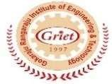
Gokaraju Rangaraju Institute of Engineering and Technology (Autonomous)
Department of Computer Science & Engineering (AIML)
Project Work – Phase II (GR22A4145)
IV B. Tech., II Semester Academic Year 2025-2026 Abstract Form
Domain | Assistive Technology, Computer Vision, Artificial Intelligence
Project Title  (Tentative) | VISIONCARE : Vision-Based Real-Time Patient Monitoring System
Team Number | AB19
Name of the Guide | Mr. Ramesh Banoth
Name of the Team  Members | Rapolu Sravani | Kuthadi Sravani | Shaik Kareena
Register Number | 22241A66B6 | 22241A6692 | 22241A66C0
Photo | 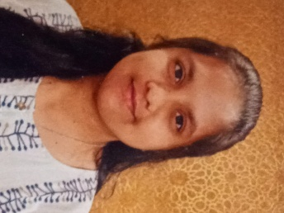 | 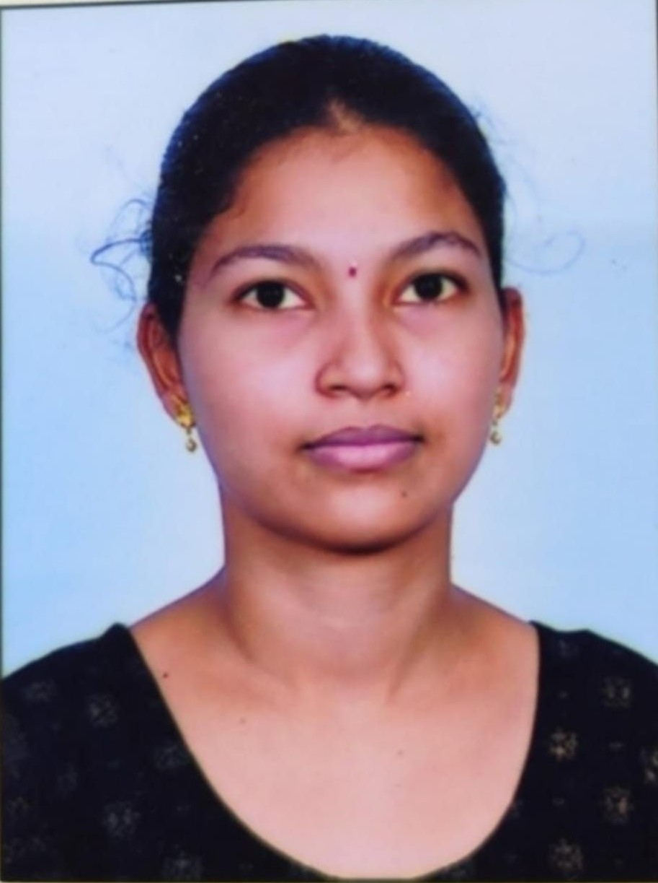 | 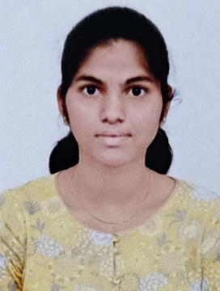
Mobile Number | +91 8317640853 | +91 6304708726 | +91 9390586987
Email-id | sravani40853@gmail.com | kuthadisravani453@gmail.com | shaikkareena1309@gmail.com
ABSTRACT
VisionCare is a vision-based real-time patient monitoring system developed to continuously observe patients and improve safety in hospital environments. In many hospitals, especially those with high patient loads, it is difficult for medical staff to monitor every patient at all times. Traditional methods rely on manual supervision or wearable sensors, which may be uncomfortable for patients and difficult to manage. In this project, the monitoring process is carried out using cameras placed in patient wards to capture live video streams. These video feeds are analyzed using computer vision and deep learning techniques to track patient movements and activities. The system is designed to identify abnormal situations such as patient falls or long periods of inactivity that may indicate a medical emergency. When such an event is detected, an alert is immediately generated to inform healthcare staff, enabling quick medical response. This approach reduces dependence on constant human supervision, avoids the use of physical sensors, and helps ensure timely assistance and improved patient care.

Signature of the Supervisor

